Order Of Service

Singing: Psalm 98—CW page 103

Reading: Psalm 61

Opening Hymn: TLH 23

Reading: Ephesians 3:1-13

Request Hymn: CW Supplement 749

Reading: Mark 11:11-19

Sermon Hymn: TLH 611

Sermon Text: Luke 22:1-6

Satan and Judas Iscariot

Prayer

The Apostles’ Creed, TLH page 12

Holy Communion

The Lord's Prayer

The Blessing

Closing Hymn: TLH 54

************

Bible Study: Lambs: TBA
Sheep: Deuteronomy 4:1-13
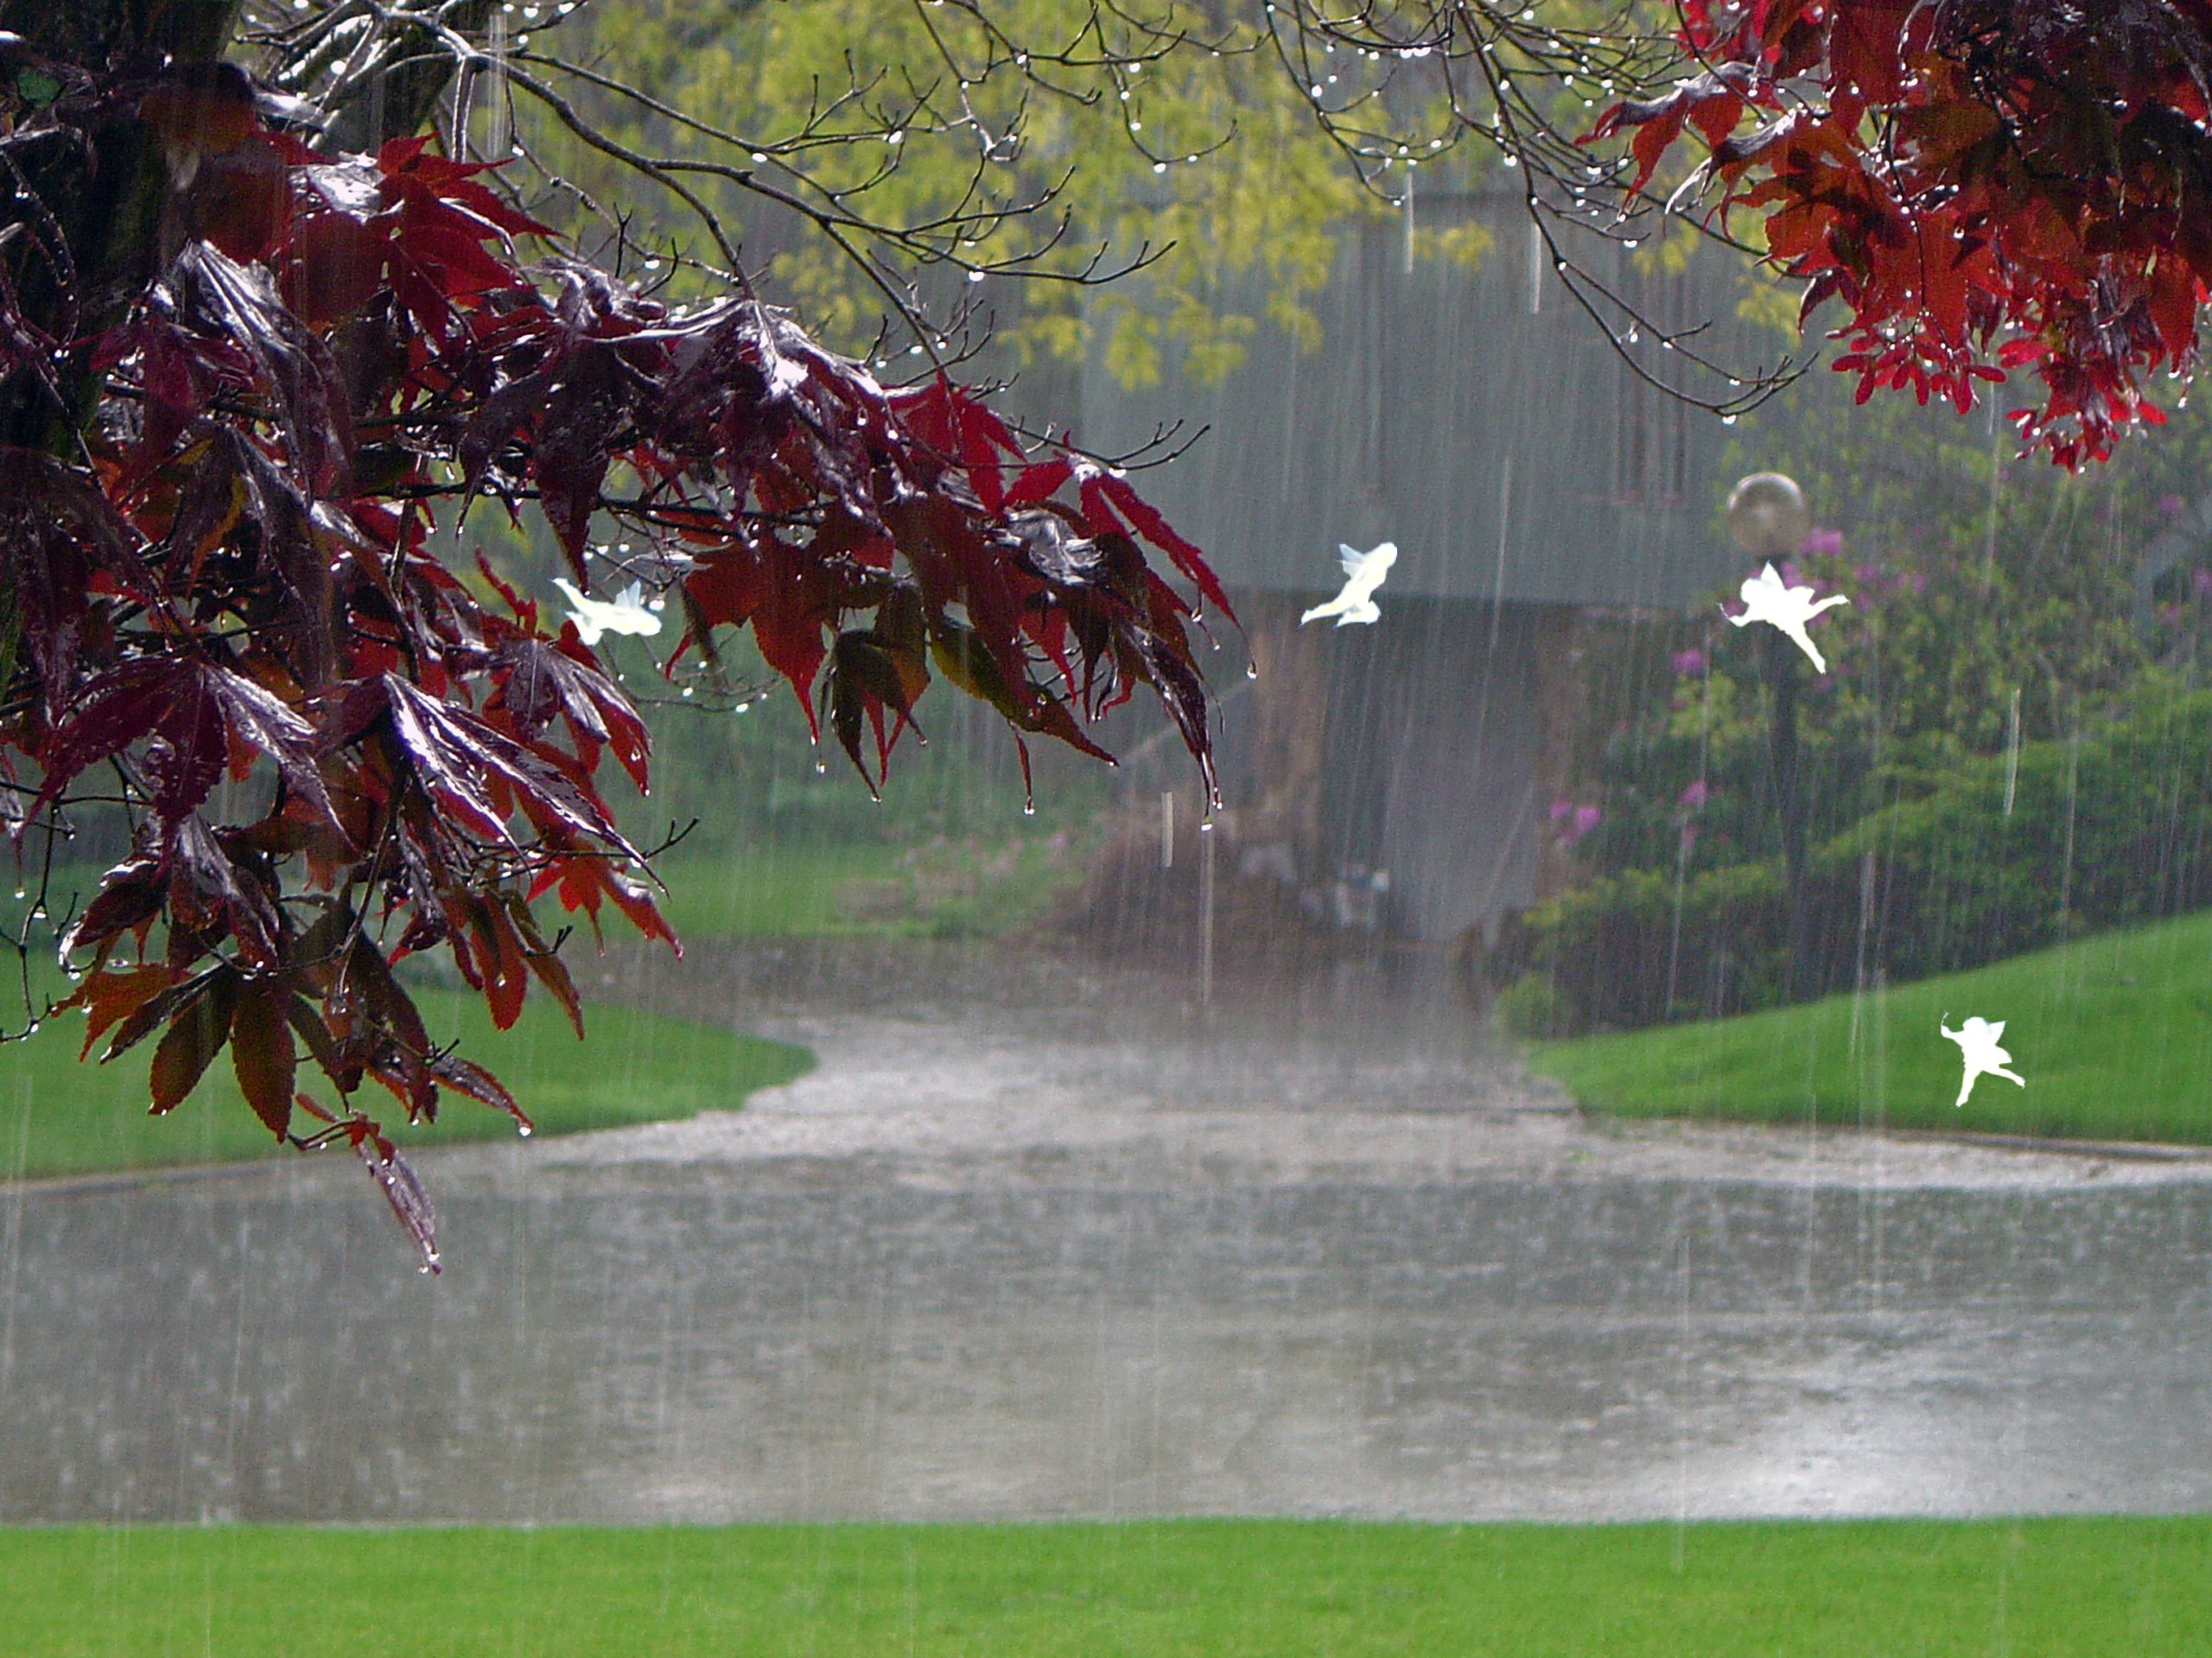

Spring Rain

Water
Of
Life

21 May 2023

W A T E R O F L I F E

Independent Christian Church—Conservative Lutheran Doctrine

Worship Service: 9:30 a.m.

Larry Cooper, Pastor E-Mail address:
lcooper@wateroflife.cc
Web Site:
www.wateroflife.cc

* * * * * * * * * * * * * * * * * * * * * * * * * * *

Sermon Text: Luke 22:1-6

Satan & Judas Iscariot

* * * * * * * * * * * * * * * * * * * * * * * * * * *

1 Now the feast of unleavened bread drew nigh, which is called the Passover.
2 And the chief priests and scribes sought how they might kill him; for they feared the people.
3 Then entered Satan into Judas surnamed Iscariot, being of the number of the twelve.
4 And he went his way, and communed with the chief priests and captains, how he might betray him unto them.
5 And they were glad, and covenanted to give him money.
6 And he promised, and sought opportunity to betray him unto them in the absence of the multitude.

